Software Design Document

for

LeTour Guide

**Prepared by**

**Group Name:** *LeTour Team*

| *Richard Homan* |
| --- |
| *Joel Wink* |
| *Cameron Bundy* |

| **Instructor:** | *Prof. Doug Lim* |
| --- | --- |
| **Course:** | *Software Engineering II* |
| **Version:** | *1.0* |
| **Date:** | *October 14, 2024* |

### CLIENT SIGN-OFF

| _____________________________ | _____________________________ | ____________ |
| --- | --- | --- |
| *print name* | *signature* | *date* |

**Table of Contents**

**1 Introduction 1**

1.1 Purpose of SDD 1

**2 General Overview / Approach 2**

2.1 General Overview 2

2.2 Goals 2

2.3 Assumptions 2

2.4 Constraints 2

2.5 Risks 2

2.6 Architectural Strategies 3

**3 Detailed Design (In Development) 4**

3.1 System Architecture Design 4

3.2 Front-end UML Diagram 5

3.3 Back-end UML Diagram 5

3.4 User Interface Flow Diagram 6

**4 Operational Scenarios 7**

5.1 Audience 7

5.2 Guide 7

# Introduction

LETU campus tours are an important experience for upcoming college students, parents, grandparents, and alumni alike. The campus tour is often the first experience interested parties have at LETU, so it is important that campus tours are comfortable for the audience. Campus tours are around 30 to 60 minutes long, and are led by a student. During preview events, held several times each year, the headcount on a single tour can vary from 20 to 50 people.

For large groups, especially in hallways where the tour may be compressed into a long line, it can be difficult for individuals in the back of a campus tour to hear the tour guide. It is important to LETU that everyone hears what the guide says. Mishearing the guide can be frustrating for the listener and can result in a more negative experience of the institution overall. Therefore, this project proposes to develop a method for using personal cell phones to facilitate a successful LETU tour experience.

## Purpose of SDD

The purpose of this Software Design Document is to outline the overall design process of the *LeTour Guide* that is easier to discuss with our client from the developers’ perspectives. Additionally, this will be used as a key reference for looking back at how our overall architecture is supposed to be set up when we start coding and do quality assurance (QA) testing.

# General Overview / Approach

## General Overview

Since this will consist of a front-end mostly controlling the intuitive user interface for both the tour guide and users and a back-end server controlling the audio streams, this will make running from any device make the LeTour guide experience more engaging.

## Goals

This project aims to create a solid foundation and highly-functional proof-of-concept that will be presented to the Admissions Department at LeTourneau University. We do not want to create a fully implemented solution to minimize the risk of wasted time if it is determined that either the project is unfeasible or that the project vision requires major modification. Secondly, the project aims to serve tour guides and tour audience members alike by assisting positively to the tour experience. The software should not be a burden, but have clear positive effects on the tour experience.

## Assumptions

It is important in any project to have as few assumptions as possible, which is our target in creating this solution. Because this solution is a proof-of-concept, it assumes that the project could be implemented in a reliable capacity on university maintained architecture. On the other hand, it also assumes that each audience member has a device capable of connecting to a university maintained network by which members could connect with the server anywhere on campus. These assumptions are meant to be resolved into requirements if this stage of the project is approved by the Admissions Department.

## Constraints

As stated in the assumptions, this stage of the project will not solve implementation with university maintained architecture. The solution should, however, be as portable as possible to make implementation as risk-free and pain-free as possible. This solution will not consider security as a large issue, but should still implement minimal security features where applicable.

## Risks

(see SPP)

## Architectural Strategies

This project is a stage in creating a feature-full and implemented tour guide solution. This project focuses on creating a solid foundation for implementing the software such that it is portable and maintainable knowing that it has a high chance of being continued by different developers. The architecture is designed to be minimal, flexible, and understandable so that it can be easily modified if it is found that the architecture should be modified. Documentation is provided in areas that need it. This includes, but is not limited to, documentation of the front-end dependencies, front-end deep logic, and back-end configuration.

## 

# Detailed Design (In Development)

## System Architecture Design

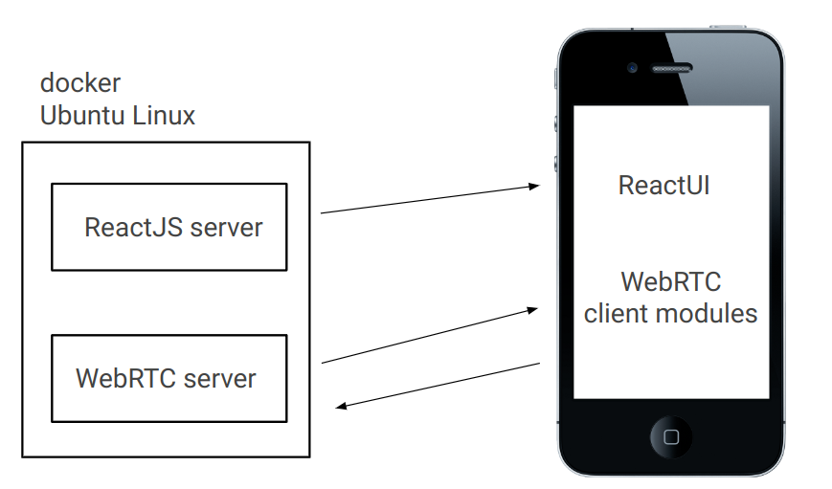

## Front-end UML Diagram

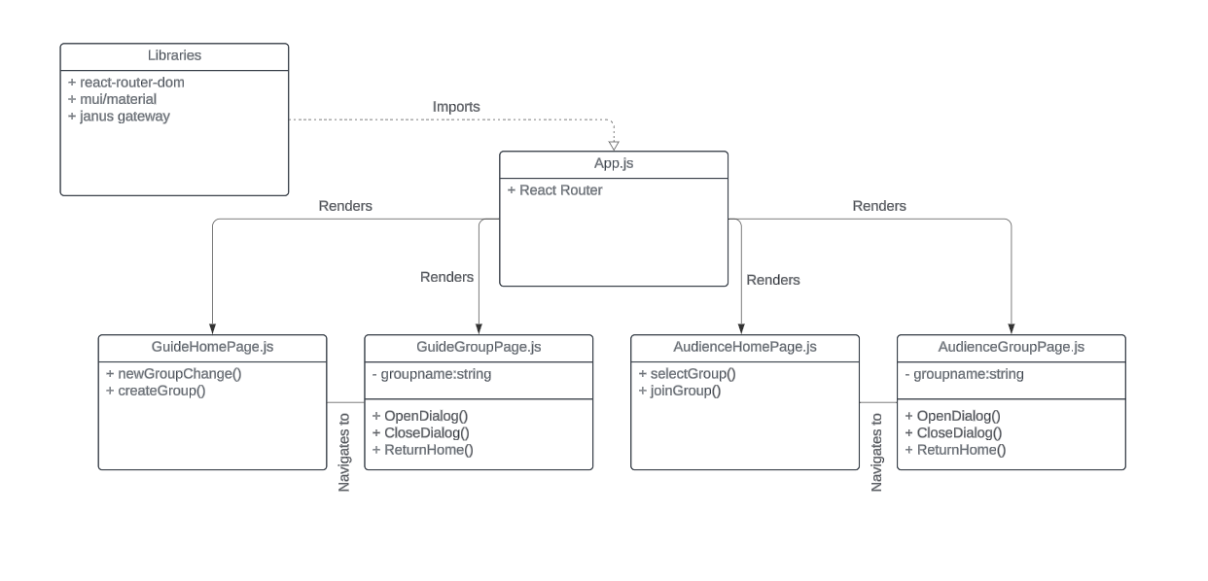

note: Check the User Interface Flow Diagram if you are looking for a State Diagram

## Back-end Configuration Diagram

The JanusRTC server is, for the most part, already fully implemented for the use case of this project. Instead, a configuration diagram is provided to show which modules of Janus are to be configured.

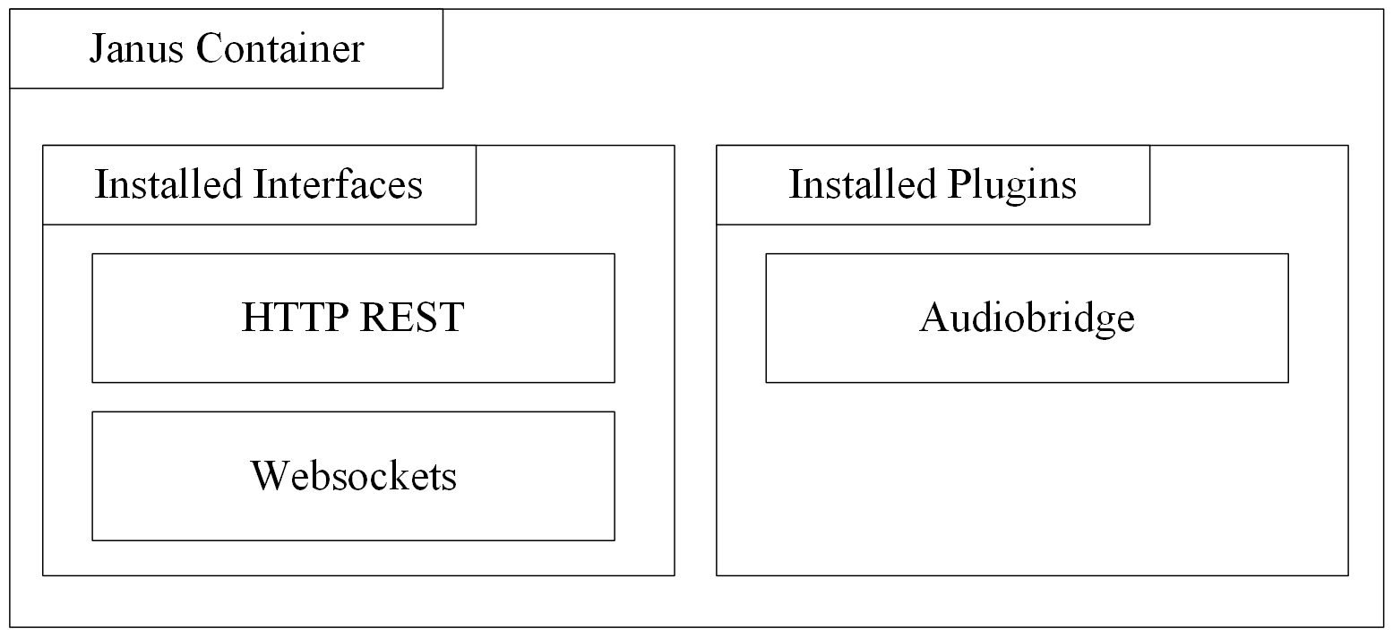

## User Interface Flow Diagram

## 

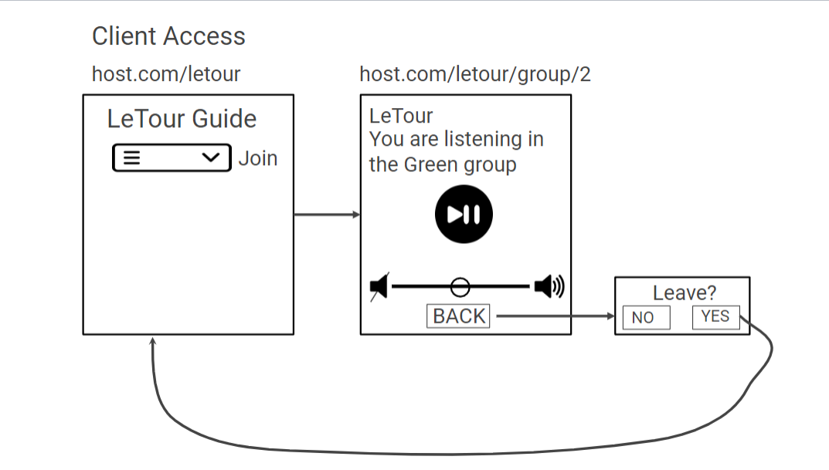

# Operational Scenarios

## 4.1 Audience

The LeTour Guide system is designed to accommodate up to 200 users, typically visitors with minimal technical expertise, such as prospective students, parents, or alumni. These users will interact with the system approximately every 3 to 4 months during campus tours that last up to 2 hours. They will access the system via a web browser on their smartphones, requiring only a stable internet connection. The primary function for these users is to listen to the tour guide clearly, regardless of their position in the group.

## 4.2 Guide

The LeTour Guide system supports up to 10 tour guides, usually student ambassadors or staff members. Like the audience, these users require minimal technical expertise and will access the system via a web browser on their smartphones for approximately 2 hours during each campus tour, occurring every 3 to 4 months. The guide will use the system to speak to the group, ensuring that their voice reaches all participants, even in large or dispersed groups, improving the overall communication and tour experience.